**ST. XAVIER’S COLLEGE**

**(Affiliated to Tribhuvan University)**

Maitighar, Kathmandu



**Computer Graphics**

**Lab Assignment #1**

**Submitted by:**

Anlisha Maharjan  
013BSCCSIT006

**Submitted to:**

**Er. Anil Sah**

Lecturer

St. Xavier’s College

**Date of Submission:** August 04, 2015

**SOURCE CODE:**

//---------------------------------------------------------------------------

#include <vcl\vcl.h>

#pragma hdrstop

#include "rectangle.h"

//---------------------------------------------------------------------------

#pragma resource "*.dfm"

TForm1 *Form1;

//---------------------------------------------------------------------------

__fastcall TForm1::TForm1(TComponent* Owner)

: TForm(Owner)

{

}

//---------------------------------------------------------------------------

void __fastcall TForm1::Button1Click(TObject *Sender)

{

Form1->Canvas->Pen->Width=3;

Form1->Canvas->Brush->Color=clWhite;

Form1->Canvas->Rectangle(20,20,200,200);

Form1->Canvas->MoveTo(20,20);

Form1->Canvas->LineTo(200,200);

Form1->Canvas->MoveTo(200,20);

Form1->Canvas->LineTo(20,200);

Form1->Canvas->MoveTo(110,20);

Form1->Canvas->LineTo(110,200);

Form1->Canvas->MoveTo(20,65);

Form1->Canvas->LineTo(200,65);

Form1->Canvas->MoveTo(20,110);

Form1->Canvas->LineTo(200,110);

Form1->Canvas->MoveTo(20,155);

Form1->Canvas->LineTo(200,155);

Form1->Canvas->MoveTo(65,20);

Form1->Canvas->LineTo(65,200);

Form1->Canvas->MoveTo(155,20);

Form1->Canvas->LineTo(155,200);

}

//-------------------------------------

**OUTPUT:**

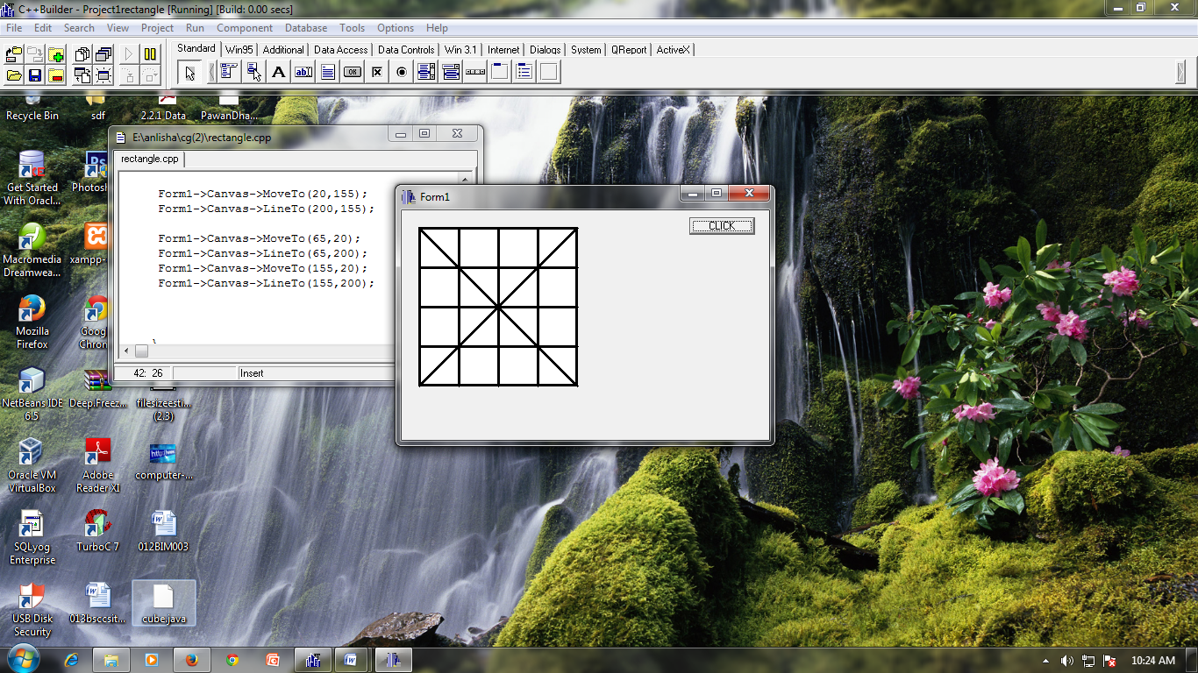

**CONCLUSION:**

Thus, in this way the checkbox was formed by use of C++ builder.